Player Details
Task
Write a query to retrieve the details of the last five matches played, including the match ID, the names of the players who participated, the name of the winning player, match date, and the final score of the winner.
There are two tables named Players and Matches.
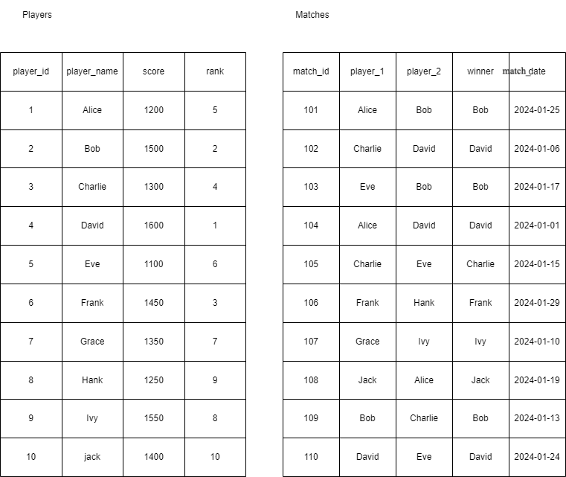
Expected Output Columns:
- match_id
- player_1
- player_2
- winner
- match_date
- score

Expected Output:
┌──────────┬──────────┬──────────┬────────┬────────────┬───────┐
│ match_id │ player_1 │ player_2 │ winner │ match_date │ score │
├──────────┼──────────┼──────────┼────────┼────────────┼───────┤
│ 106 │ Frank │ Hank │ Frank │ 2024-01-29 │ 1450 │
│ 101 │ Alice │ Bob │ Bob │ 2024-01-25 │ 1500 │
│ 110 │ David │ Eve │ David │ 2024-01-24 │ 1600 │
│ 108 │ Jack │ Alice │ Jack │ 2024-01-19 │ 1400 │
│ 103 │ Eve │ Bob │ Bob │ 2024-01-17 │ 1500 │
└──────────┴──────────┴──────────┴────────┴────────────┴───────┘

